**Customer Lifetime Value**

**Wireframe Documentation**

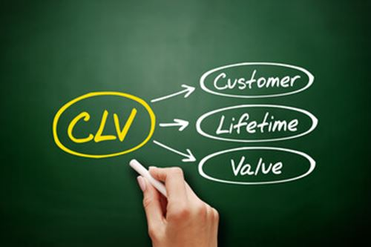

**Project On:**

**Title : Customer Lifetime Value**

**By: Rushikesh Khandare**

Homepage:

As per the problem statement we have created a dashboard.

Dashboard:

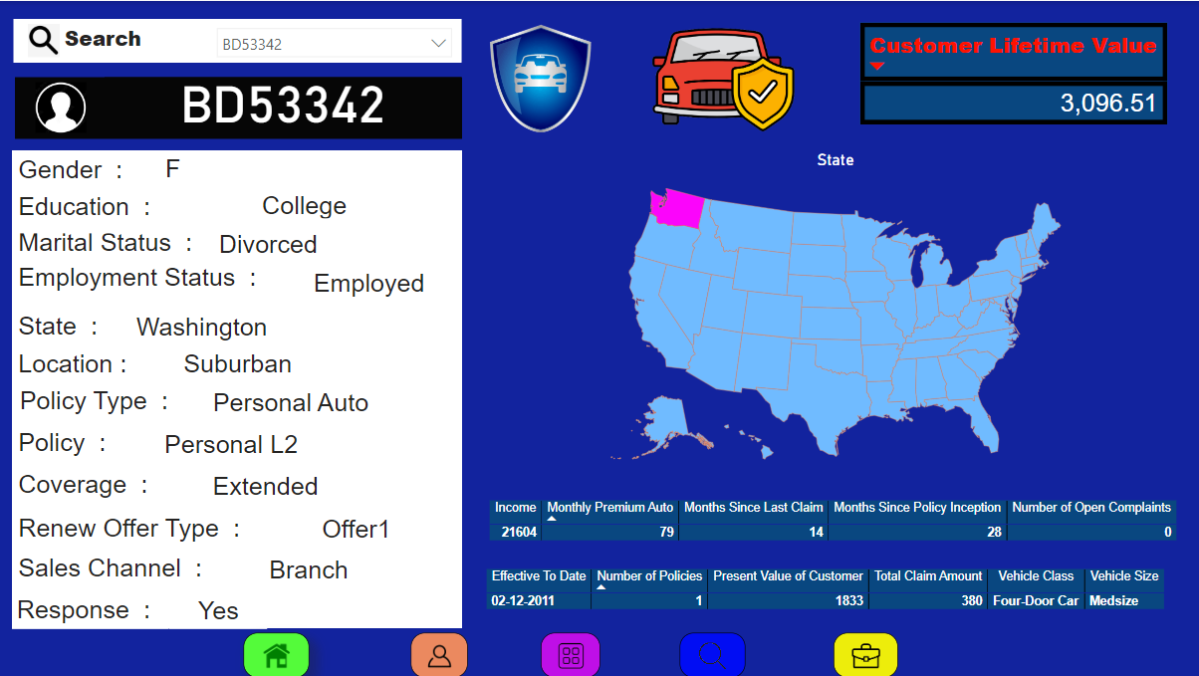

NovyPro Link :- [*https://project.novypro.com/2N4BhG*](https://project.novypro.com/2N4BhG)

Github Link :-  *https://github.com/Rushi9867/Customer-Lifetime-Value*